Report for password encryption

This is a great python project. I haven’t touched python for almost two years. This project helps me refresh all of my python knowledge.

My idea of this project:

1. I read the dictionary file ( /usr/share/dict/words ) and implement all the rules on the words, I also created a file for saving all the digit words and implement all the rules on these digit words as well. Then I hashed all the words (letters and numbers ) using “sha256()”, and put the results to txt file with the original password. The format is as followed:

1324e5549f6e1c9566708aa0a4de7b59a56ac7bc5868bb57bbd2bb1436155bfc:Aaliyah0

2. I read each line of the “crackme.txt” file and split each line using the method “split(“:”)”, then put the line that has been split into the list and save the second part of the element in the list into “input.txt” file.

3. Then I use for loop to go through the “input.txt” file and compare with the digit words file(“digit.txt”) and dictionary words file(“words.txt”). If I find the 64 length strings are the same, then print out the password from the “digit.txt” and “words.txt” and save the output into “output.txt”.

The speed of my project is not too fast because I have to read all the file and write into a new file, then read the new file again, which it’s not efficient. However, we have to put all the hashing results somewhere in order for us to retrack the password. I guess the way to improve is that we can implement a 2D array to save the 64-length string and password instead of writing them into a txt file, then we do have to access the external files.

The main issues I had:

There are two txt files, input.txt should be empty. Crackme.txt is file we need to crack.

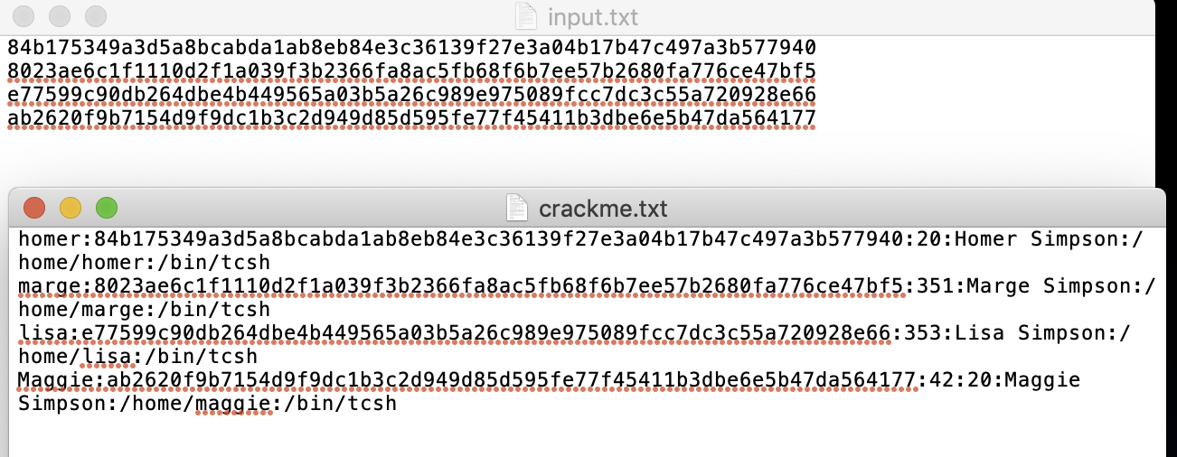

Then I run the part of my code as below. I read “crackme.txt” and use for loop to read each line and split each by “:”, then put each part into a list, call “au”. The list should look like

[“homer”, “84b1………….7940”, “20”, “Homer”, “Simpson”, “home”, “homer”, “bin”, “tcsh”]

Then I only write au[1] to “input.txt”.

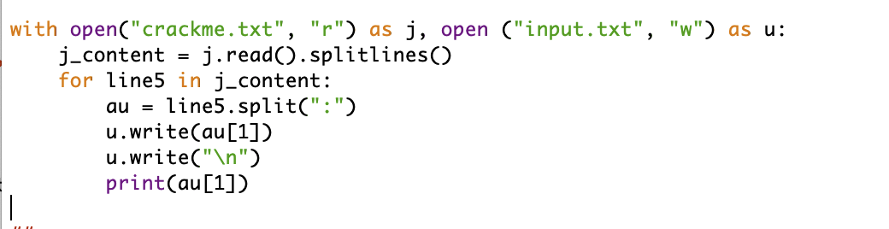

When I run the code, it writes what I want into “input.txt” and also can be print out. But it gives me the index error: list index out of range.